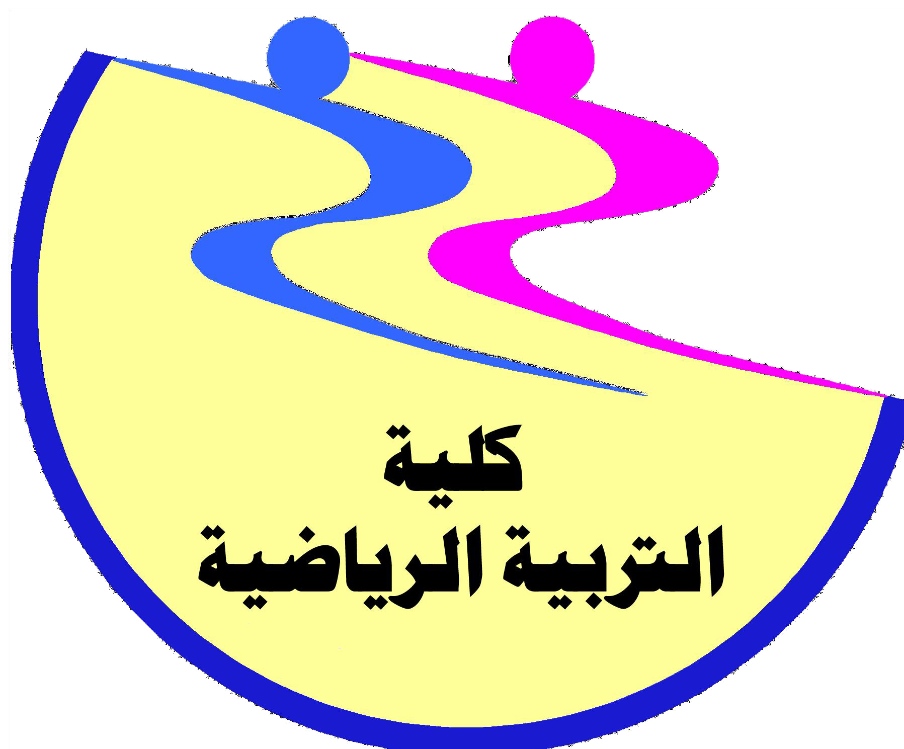
Assiut University
Faculty of Physical Education
Department of Curriculum and teaching physical education
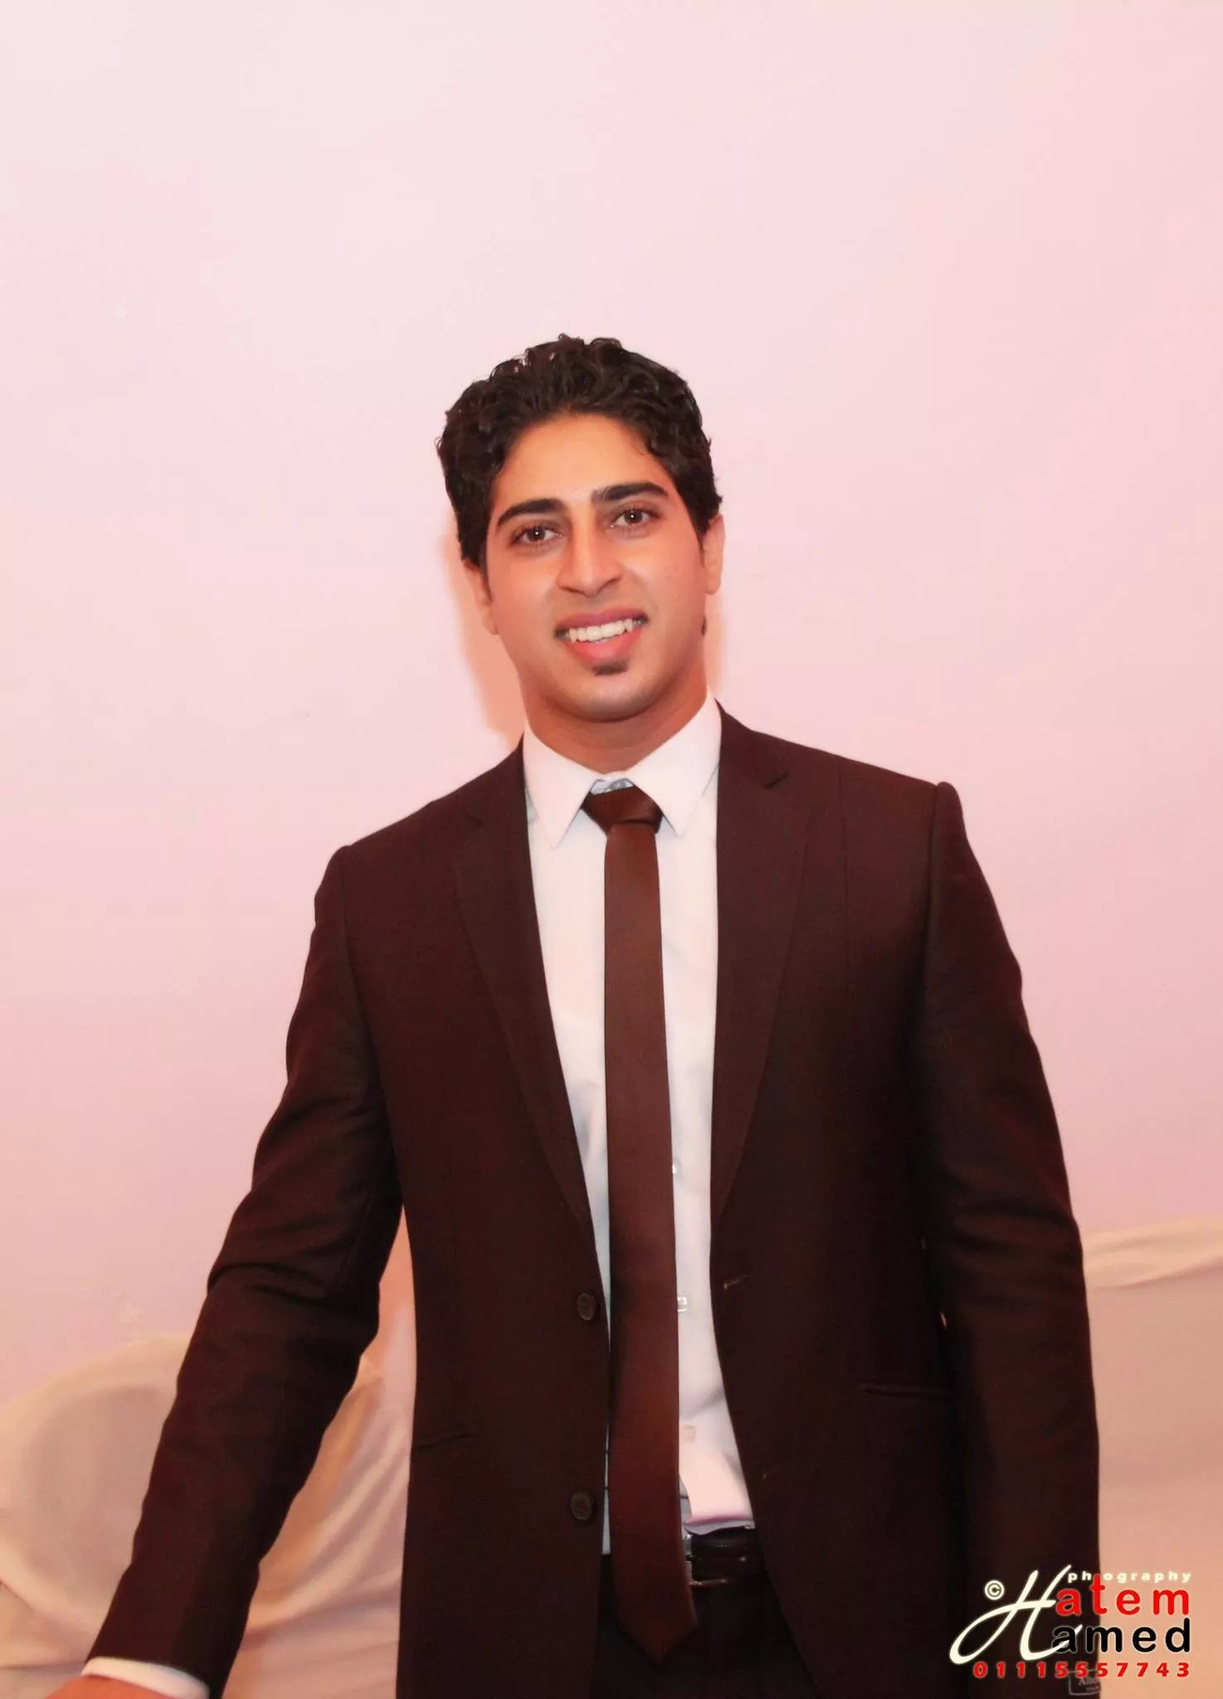
Biographical statement for faculty members

First: personal data

Bassam elsayed Mohamed

Birthday | : | 2/2/1989 | nationality | : | Egypt
Marital status | : | Unmarried | Religion | : | muslim
Email | : | dr.bassam_elsayed@yahoo.com
Telephone | : | 01060800298
Second: Current job data

job | : | Assistant teacher
Organization It | : | Faculty of Physical Education - Assiut University
Scientific department | : | Department of Curriculum and teaching physical education
General Specialization | : | Teaching physical education
Specialization | : | Teaching track and field competitions
Thir-qualifications and degrees

Qualified name | Hand get it | Specialization | Date of acquisition
Bachelor of Physical Education | Faculty of Physical Education - Assiut University | Athletics | 2011
- Master of Physical Education | Faculty of Physical Education - Assiut University | Athletics | 2015

Fourth: the gradient job
- - Lecturer in the Faculty of Physical Education, Assiut University from 2012
- Assistant Lecturer, Faculty of Physical Education, Assiut University from 2015.
Fifth: scientific and practical experiences

Ruling third degree Egyptian Federation of athletics.
- Participation in the preparation and organizing a number of seminars at the Faculty of Physical Education.
- Give lectures in the field of athletics at the Faculty of Physical Education for specialized role established the Faculty of Physical Education, Assiut University - Guild sports and professions.
- Participation in the organization of environmental day of the University in 2010- 2011 m.
- Participation in the organization on the orphan college in 2013 - 2014 – 2015

- Experiences in athletics
First - as a player:
- Gradient university's strong national team for the Games until 2009
- Such as the university team until the year 2011 and holds first place in many races

Second, as a coach:

- Get Aldroh specialized training in athletics provided by the Egyptian Federation Athletics Association and sports professions.
- Get role Althikm the third degree from the Egyptian Athletics Federation.
- Coach college team Athletics Benin 2013 m - 2014 to 2015 m.
- Coach of the University Athletics Benin in 2014 - 2015 m.

